**SOFTWARE TESTING STYLES**

**1. BLACK BOX TESTING**

**Definition:**  
Black Box Testing is a method of software testing where the internal structure, design, and implementation of the application are not known to the tester. The tester focuses only on the inputs and expected outputs. 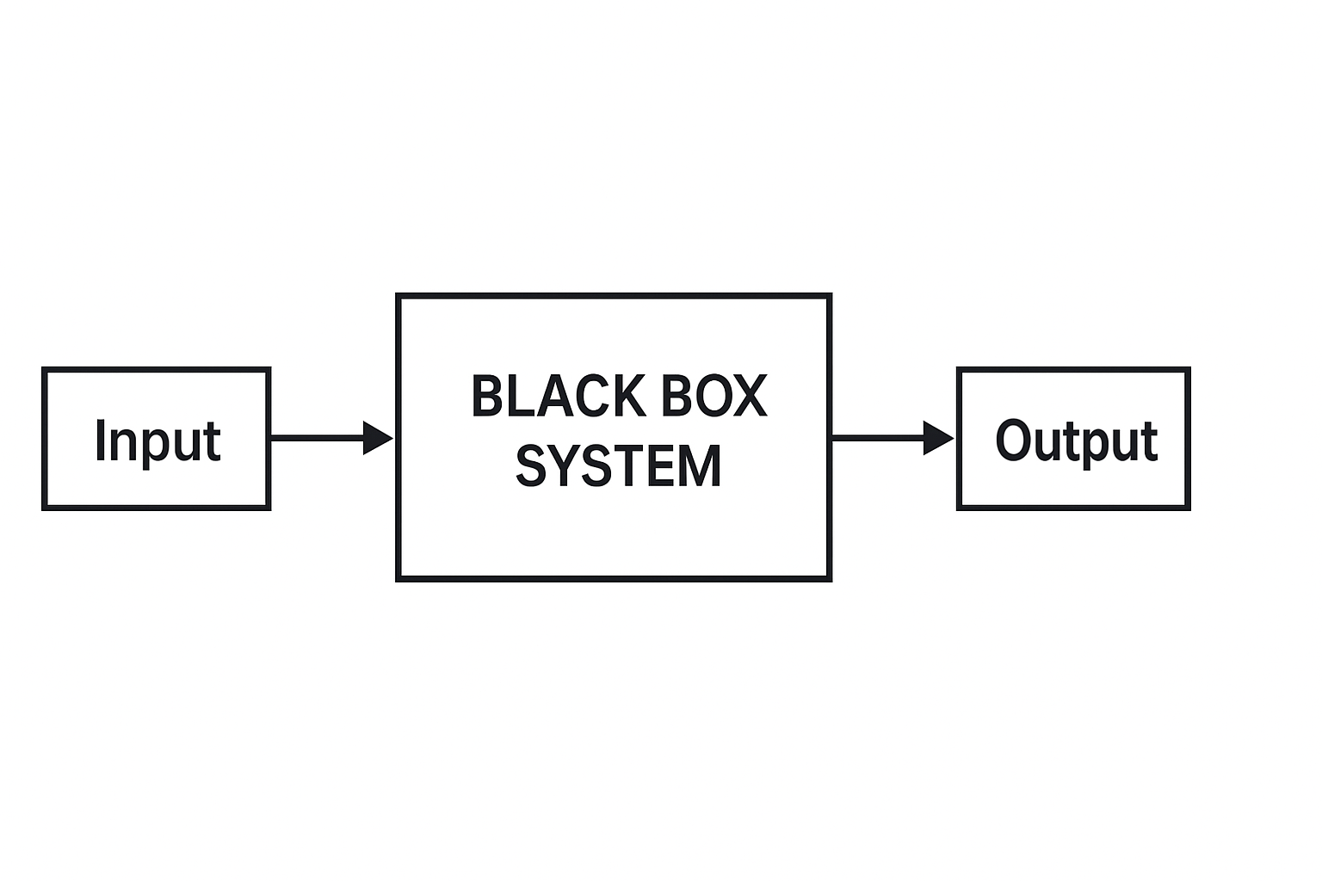

**Purpose:**

* To validate that the software performs as per the functional requirements.
* To uncover errors in functionality, interface, and performance.

**Advantages:**

* No need for programming knowledge.
* Helps detect ambiguity in the specifications.
* Tests are done from a user’s point of view.

**Disadvantages:**

* Limited coverage as only a few paths are tested.
* Difficult to design test cases without clear requirements.

**Examples:**

* Testing a login page with valid and invalid inputs.
* Checking if a calculator gives the correct sum without knowing the underlying code.

**2. WHITE BOX TESTING**

**Definition:**  
White Box Testing is a software testing technique where the internal structure, design, and coding of the software are known to the tester. The tester validates internal logic and structure.

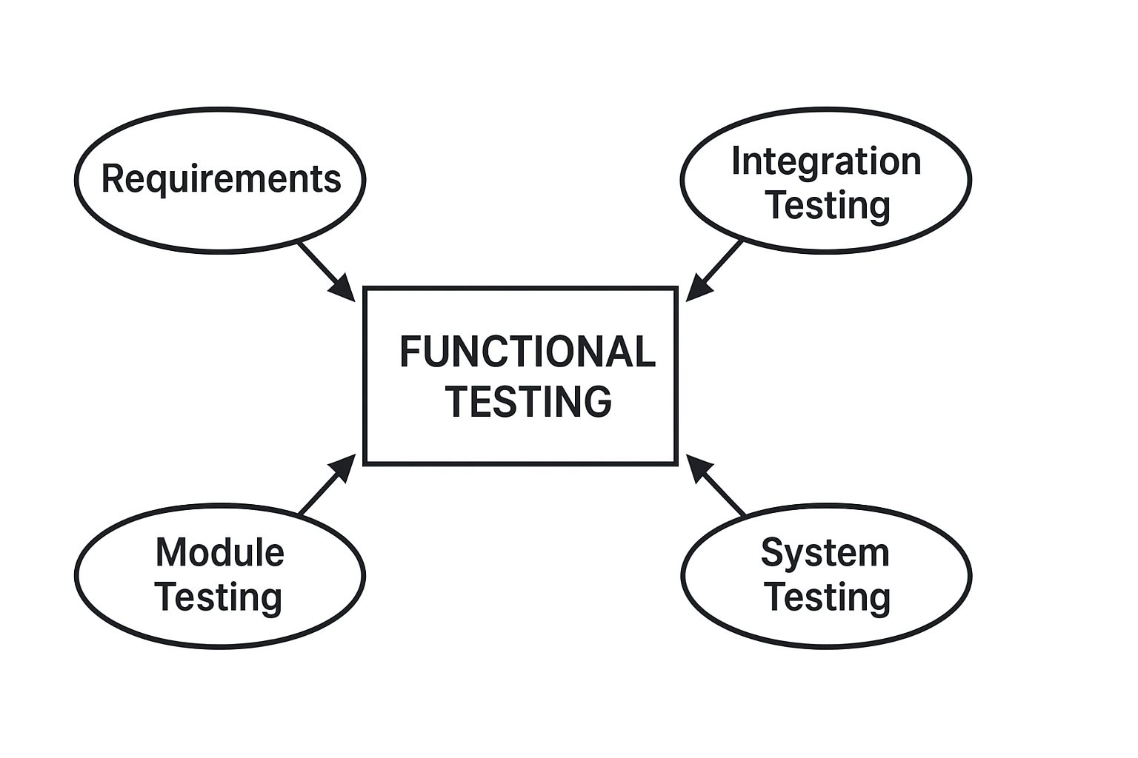

**Purpose:**

* To test specific code paths and conditions.
* To ensure code accuracy, security, and quality.

**Advantages:**

* High code coverage.
* Efficient in finding hidden errors and optimization opportunities.

**Disadvantages:**

* Requires skilled testers with programming knowledge.
* Can be time-consuming and expensive for large projects.

**Examples:**

* Unit testing individual functions by verifying all loops and branches.
* Testing the algorithm flow inside a banking software system.

**3. REGRESSION TESTING**

**Definition:**  
Regression Testing is the process of re-running functional and non-functional tests to ensure that previously developed and tested software still performs after a change.

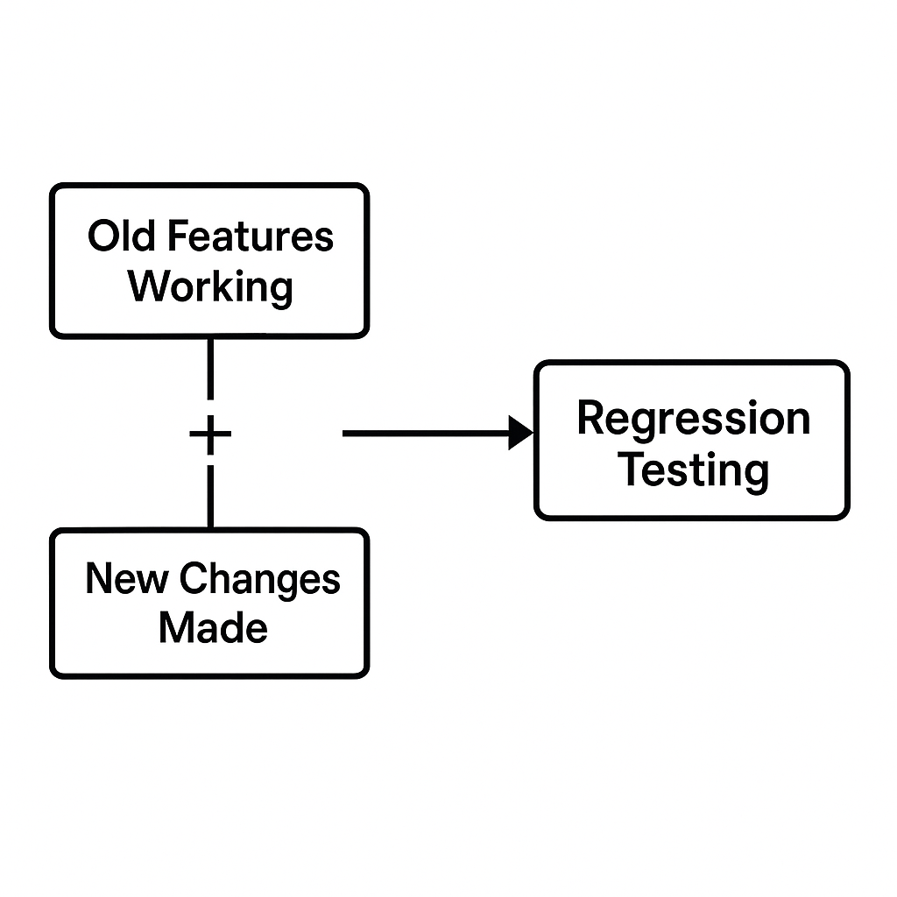

**Purpose:**

* To detect side effects after code modifications.
* To maintain software stability.

**Advantages:**

* Ensures that old features work along with new changes.
* Reduces risk of bugs in production.

**Disadvantages:**

* Can be repetitive and tedious without automation.
* Requires constant updating of test cases.

**Examples:**

* Testing a payment system after adding a new promotional code feature.
* Re-running all test cases after bug fixes to check overall system behavior.

**4. SMOKE TESTING**

**Definition:**  
Smoke Testing is a preliminary level of testing to reveal simple failures severe enough to reject a prospective software release. It verifies basic functionalities.

**Purpose:**

* To quickly check whether the major functionalities are working.
* To decide if a build is stable enough for further testing.

**Advantages:**

* Saves time by rejecting unstable builds early.
* Simple and easy to perform.

**Disadvantages:**

* Not a substitute for full testing.
* May miss deeper hidden defects.

**Examples:**

* Checking if a newly installed application launches and basic navigation works.
* Verifying if user login and logout functions are operational after a software update.

**5. ACCEPTANCE TESTING**

**Definition:**  
Acceptance Testing is the process of verifying that a software system meets the business requirements and is acceptable for delivery to the customer.

**Purpose:**

* To confirm the software is ready for deployment.
* To validate that it meets user needs and expectations.

**Advantages:**

* Builds client confidence in the product.
* Ensures the software serves its intended purpose.

**Disadvantages:**

* It can be subjective and vary from client to client.
* Feedback may require multiple iterations and improvements.

**Examples:**

* A user testing an e-commerce website to ensure products can be purchased smoothly.
* A client testing a healthcare app to verify that patient records are saved correctly.

**CONCLUSION**

Software testing plays a vital role in ensuring the quality and success of a software product. Each testing style brings unique strengths to the software development process.Black Box Testing helps in verifying the application from a user’s perspective without focusing on internal details.White Box Testing, on the other hand, dives deep into the code to ensure logical correctness and secure operation.Regression Testing is critical in maintaining the consistency of software performance after updates and bug fixes.Smoke Testing acts as a first-level check to identify critical issues early in the development cycle.Finally, Acceptance Testing confirms that the software meets business requirements and is ready to be released to users.In today’s fast-paced development environment, these testing styles are often combined to achieve maximum coverage and reliability. Automation tools and Agile methodologies have made it easier to integrate continuous testing into the software lifecycle.A strong testing strategy ensures that software products are reliable, secure, and meet the expectations of end-users. Effective testing ultimately leads to higher customer satisfaction, reduced maintenance costs, and a better reputation for developers and companies.Software testing is not just a technical necessity; it is a crucial investment in building quality products that users can trust and rely on.